# 403-Forbidden error-while accessing the gui trnsactions

Now we are seeing 403-Forbidden about when we are accessing the REPORTS/Normal Report applications to the Fiori Launchpad

in fiori launchpad some of the gui transactions already added to the fiori launchpad.

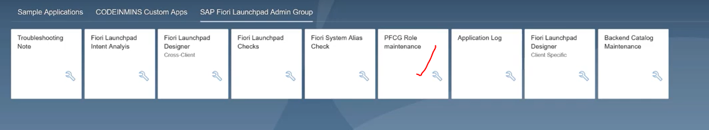

click on pfcg role tile.. it is navigating to the GUI: pfcg tcode.(gui accessing)--> when you click on this--> you will get the 403-forbidden error.

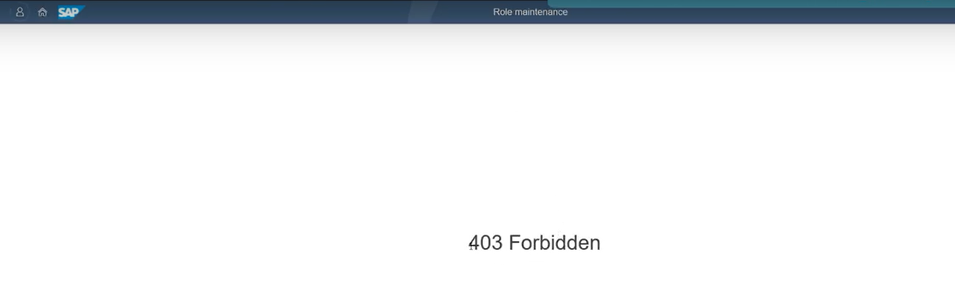

FOR GUI trnsactions: WEBGUI service needed

How to resolve the error is:

to resolve this --> login to the SAP system --> go to SICF tcode check the : webgui service activated or not --> if it is not activate you will get the error.

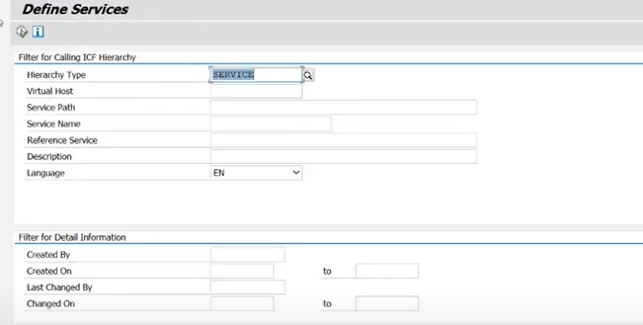

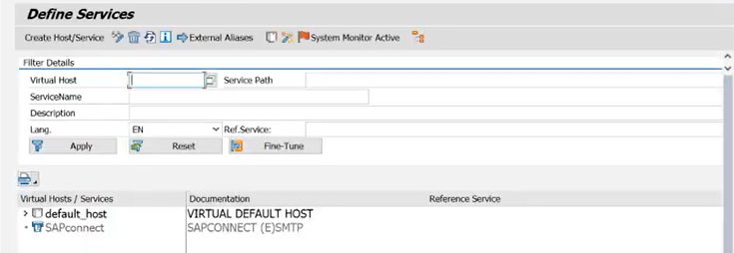

filter with webgui service.

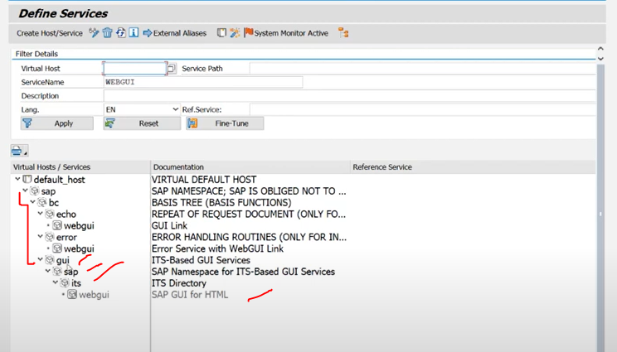

/sap/bc/gui/sap/its/webgui <-- now here it is not activated.

right click on activate the webgui service.

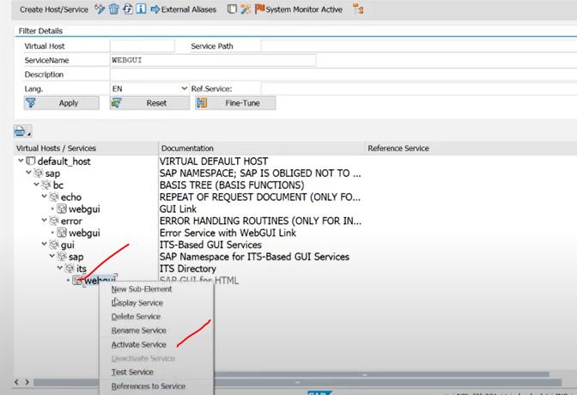

if you click on Yes --> particular node will be activate

if you click on tree yes --> particular node and corresponding child nodes also activate. <-- try to use this only

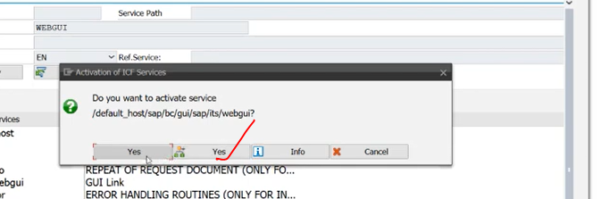

Now go to Home Page

click on PFCG tile -->

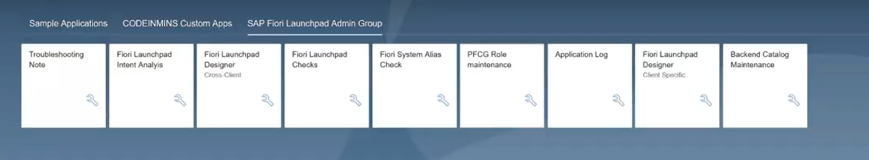

Now it is redirect to the PFCG tcode SAP backend --> you will not get the error.

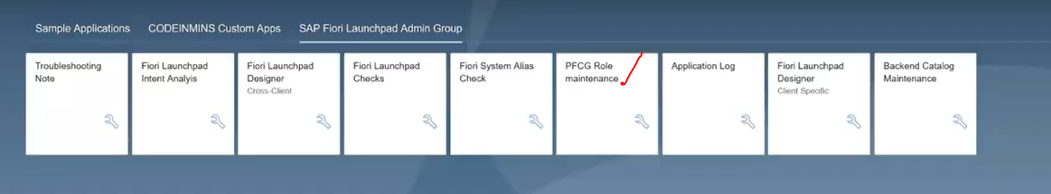

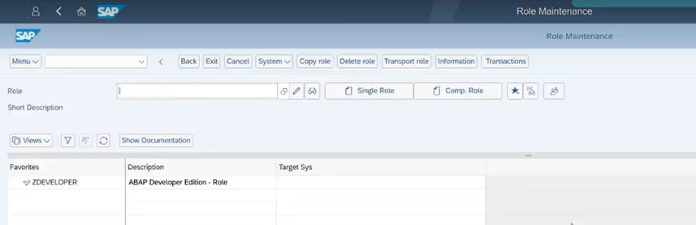

open gui tcode.